Computer componants

The computer contains two main parts which are:
- Hardware : Think of computer hardware as the components of your computer that you can see and touch. These are the tangible components that are likely mounted in your computer's case and installed with a screwdriver.
- Software : Computer software, on the other hand, is not physically accessible, but is the programs you install on your computer, and provides a set of instructions telling your computer how to operate.

Example of software :
- Windows 10
- macOS
- Microsoft Office
- Adobe Acrobat Reader
- Logiciel de sécurit

Example of hardware :
- Motherboard
- Processor (CPU)
- Random Access Memory (RAM)
- Storage disk (hard drive or SSD)
- Graphics Processing Unit (GPU)
- Keyboard, mouse and screen

Motherboard:
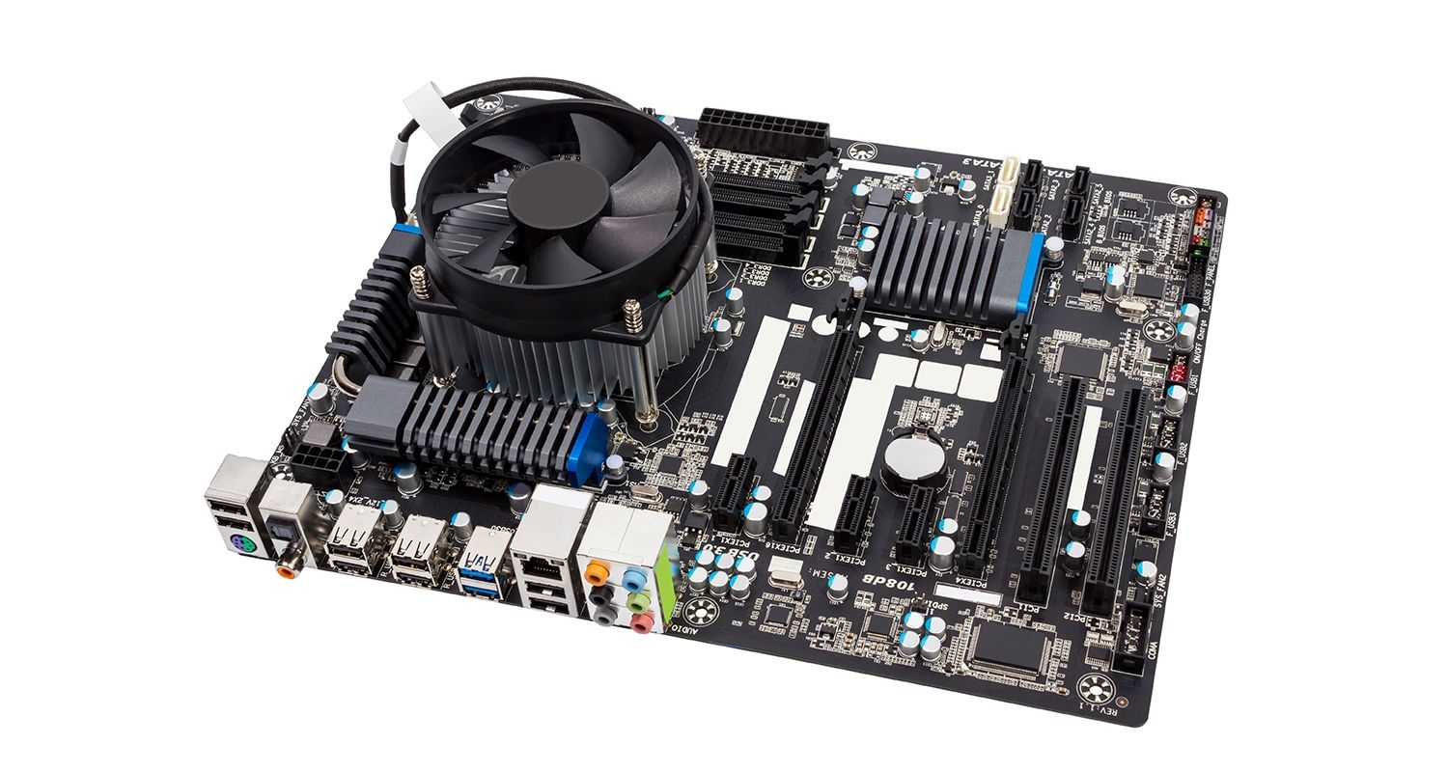

The motherboard is the main part inside a computer that connects all the other parts together.
It’s like a big board that holds the CPU, RAM, storage, graphics card, and other parts and helps them work as one system.

Cpu:
The CPU stands for Central Processing Unit.
It’s often called the "brain" of the computer because it does all the thinking and calculations. Whenever you open an app, play a game, or type something the CPU is the part that makes it happen.
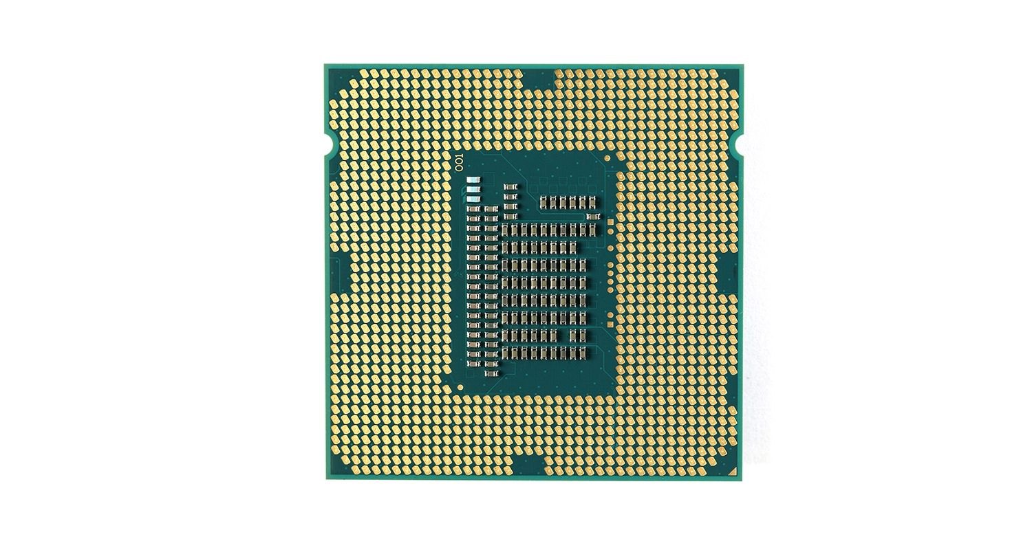

RAM(Random Access Memory):
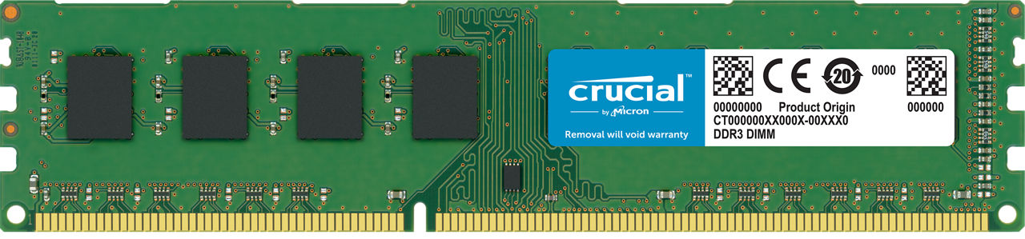

RAM stands for Random Access Memory.
It’s like your computer’s short-term memory it remembers things while you’re using them, but forgets everything when the computer turns off.

ROM(Read-only memory):
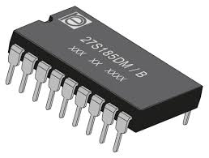
ROM stands for Read-Only Memory.
It’s a type of permanent memory in a computer — it stores important instructions that don’t change and are needed to start the computer.

SSD(solid state drive):
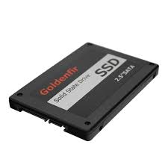

SSD stands for Solid State Drive.
It’s a type of storage for your computer where your files, games, apps, and the operating system (like Windows) are saved.

HDD(Hard Disk Drive):

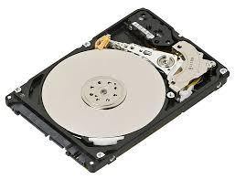

HDD stands for Hard Disk Drive.
It’s a type of storage device in a computer that saves all your files, like photos, videos, games, apps, and the operating system (like Windows).

The difference between SSD and HDD :
Both SSD and HDD both are storage devices they store your files, like games, apps, photos, and the operating system.but they work differently

 | hdd | sdd
Cost | cheaper | More expeensive
Noise | Can make noise | Completely silent
Power use | Uses more power | Uses less power
Speed | slower | Much faster

GPU(Graphic Processing unit)/Graphic card:
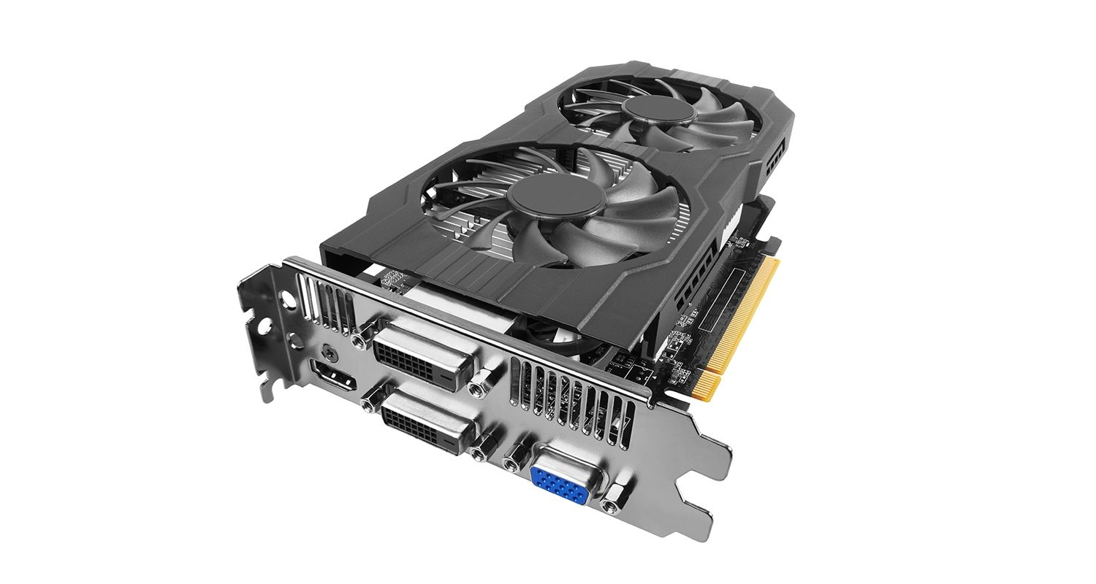

is a part of the computer that creates and displays images on the screen. It handles everything you see, like:
- Games
- Videos
- Animations
There is two types of GPU’s:
Integrated GPU | Built into the CPU, good for basic tasks
Dedicated GPU | A separate graphics card. Best for gaming, video editing, 3D work.

PSU(Power Supply Unit):
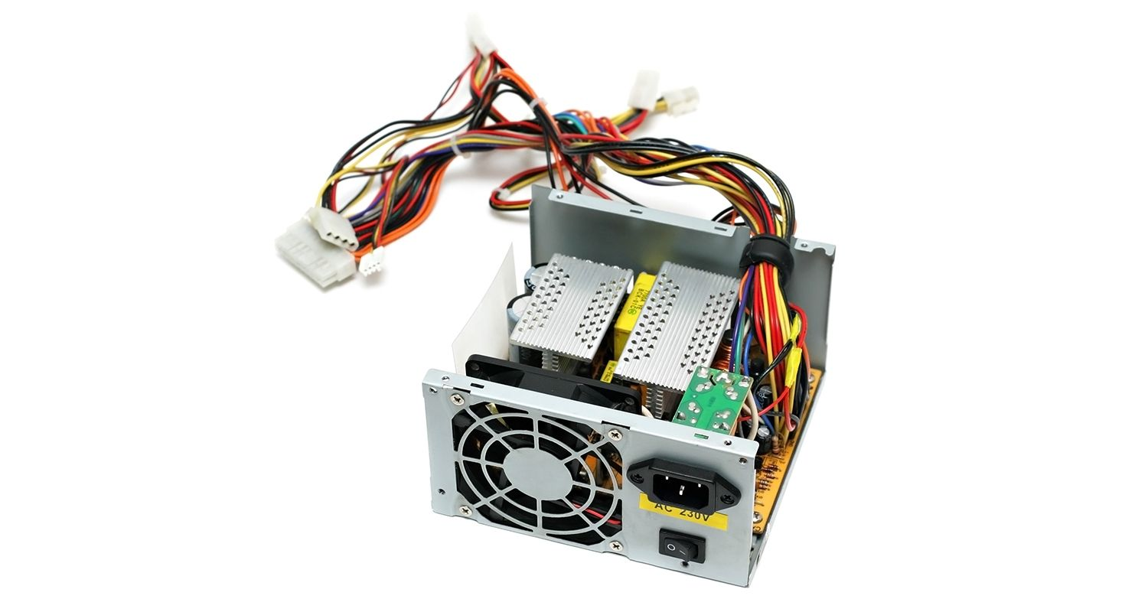

is the part of the computer that gives power to all the other parts like the motherboard, CPU, graphics card, hard drives, etc.

What Does It Do?
- Converts electricity from your wall (AC power) into the type your computer needs (DC power)
- Distributes power to every part of your computer using cables
- Protects your computer from power surges or problems

Connecteurs:

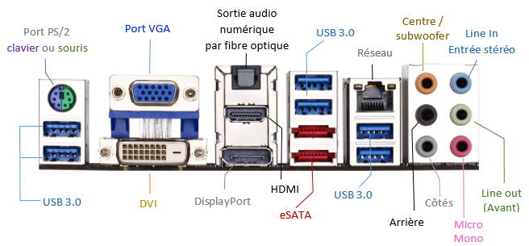

re the plugs, ports, or cables that are used to connect different parts of a computer together or to connect external devices like a mouse, keyboard, monitor, or charger.

Types of Computer Connectors:

Internal Connectors (inside the computer):
- Power connectors (from PSU to motherboard, CPU, graphics card)
- SATA connectors (to connect hard drives and SSDs)
- Front panel connectors (for power button, USB ports, etc.)
- RAM slots and PCIe slots (for memory and graphics cards)

External Connectors (on the outside of your PC or laptop):
Connector Type | What It’s Used For
USB | Mouse, keyboard, flash drives, phones
HDMI / DisplayPort | Connect monitor or TV
Audio jack (3.5mm) | Headphones or speakers
Ethernet (RJ45) | Wired internet connection
Power connector | Plugging your computer into the wall

Pc cooler:

1. Air Cooler
- Uses a metal heatsink and fan to blow hot air away from the CPU
- Most common and affordable
- 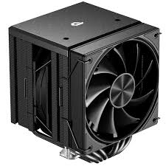

2. Liquid Cooler / Water Cooler
- Uses liquid and a radiator to cool down the CPU
- More powerful and quieter, often used in gaming or high-performance PCs
- 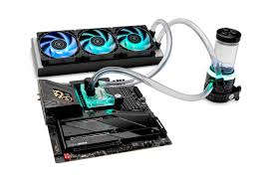

3. Case Fans
- Located in the PC case
- Pull cool air in and push hot air out to keep the whole system cool
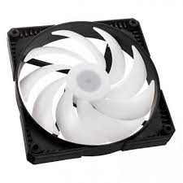

POST(Power-On Self-Test):
It’s the first thing your computer does when you turn it on a quick check-up to make sure all the main parts are working properly.

It checks:
- CPU (is it working?)
- RAM (is it installed and okay?)
- Motherboard
- Graphics card
- Keyboard
- Drives (HDD/SSD):

BIOS(Basic Input Output System):
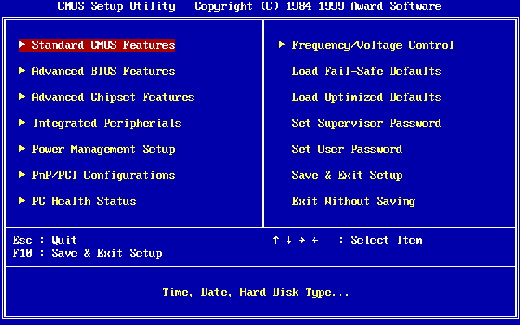

It’s a small program stored on a chip on the motherboard that helps your computer start up and controls communication between the hardware (like the CPU, RAM, and drives) and the operating system (like Windows).

What does it do:
- Runs the POST (Power-On Self-Test) to check hardware
- Loads the bootloader to start your operating system
- Lets you change hardware settings (like system time, boot order)
- Helps the CPU and other parts talk to each other before the OS takes over

COMs (COM Ports):
COM ports are special ports that let your computer send and receive data one bit at a time to other devices.
- COM ports were very common before USB became popular.
- They use serial communication, which means data goes through one wire at a time.
- On modern computers, physical COM ports are rare but you can still find virtual COM ports for certain devices.

UEFI ( Unified Extensible Firmware Interface):
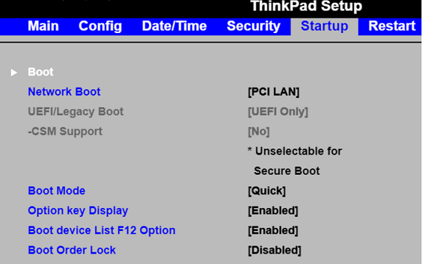

It’s a modern version of the old BIOS it’s the software your computer uses when it first turns on to start the hardware and launch the operating system.
UEFI is the new way computers start up and talk to their hardware before loading Windows or another OS.

Feature | BIOS | UEFI
Age | Older technology | Modern replacement for BIOS
Interface | Text-based, simple menus | Graphical, mouse-friendly menus
Boot Speed | Slower | Faster boot times
Disk Support | Limited to drives under 2 TB | Supports drives larger than 2 TB
Security Features | Basic | Advanced security like Secure Boot
Network Support | Limited | Can connect to network during boot

